Full Stack Development with MERN
Project Documentation format
1. Introduction
Project Title: HouseHunt – Finding Your Perfect Rental Home
Team Members & Roles:

- Siva Manikanta Baswa – Team Lead & Frontend Developer
- Venkata Surya Vikram Nakka – Frontend Developer
- Vijay Vardhan Nathi – QA & Testing
- Narshe Harshini – Backend Developer

2. Project Overview
Purpose:
HouseHunt is a web-based platform designed to help users find rental properties, apartments, and houses efficiently. It connects renters with property owners and provides a seamless booking process while ensuring secure and user-friendly interactions.
Features:
- Renter Registration & Login
- Owner Registration & Property Management (Add/Edit/Delete)
- Property Search with Filters (Location, Price, Bedrooms, Amenities)
- Booking Request & Approval Workflow
- Dashboard for Admin, Owner, and Renter
- Real-time Notifications for Booking Status
- Secure Authentication & Authorization
- Image Upload for Property Listings

3. Architecture
Frontend (React.js):
- Built using React.js with Bootstrap and Material UI for styling.
- Axios library used for connecting with backend REST APIs.
- Components structured for reusable UI elements such as forms, cards, and dashboards.
Backend (Node.js & Express.js):
- REST API architecture using Express.js.
- Routes divided based on functionality: auth, property, booking, and admin.
- Middleware implemented for authentication and error handling.
Database (MongoDB):
- NoSQL database to store users, properties, and bookings.
- Collections:
  - users – stores user details (name, email, password, type)
  - properties – stores property info (ownerId, type, address, rent, availability, images)
  - bookings – stores booking requests (userId, propertyId, ownerId, status)
- Mongoose ODM used for schema definition and CRUD operations.

4. Setup Instructions
Prerequisites:
- Node.js & npm
- MongoDB (local or Atlas)
- Git
- Browser (Chrome/Firefox)
Installation Steps:
- Clone the repository:
git clone [repository link]
- Backend setup:
cd backend
npm install
- Create a .env file with:
PORT=5000
MONGO_URI=[Your MongoDB Connection String]
JWT_SECRET=[Your JWT Secret]
- Start the server:
npm start
- Frontend setup:
cd frontend
npm install
npm start
- Access the app at http://localhost:3000

5. Folder Structure
Client (React):
frontend/
├── src/
│ ├── components/ # UI components
│ ├── pages/ # Pages like Home, Dashboard, Login
│ ├── services/ # Axios API calls
│ ├── App.js
│ └── index.js
└── package.json
Server (Node.js/Express):
backend/
├── controllers/ # Controller logic
├── middlewares/ # Auth and error middlewares
├── models/ # Mongoose schemas
├── routes/ # API routes
├── config/ # DB connection
├── .env
├── index.js
└── package.json

6. Running the Application
Frontend:
cd frontend
npm start
Backend:
cd backend
npm start

7. API Documentation
Sample Endpoints:
- POST /api/auth/register – Register new user
- POST /api/auth/login – Login user
- GET /api/properties – Fetch all properties
- POST /api/properties – Add a new property (Owner only)
- PUT /api/properties/:id – Update property (Owner only)
- DELETE /api/properties/:id – Delete property (Owner only)
- POST /api/bookings – Send booking request
- PUT /api/bookings/:id – Approve/Reject booking (Owner only)
Request & Response example available in Postman collection.

8. Authentication
- JWT-based authentication implemented for all protected routes.
- Roles: Admin, Owner, Renter
- Access control middleware verifies JWT and user type for route authorization.

9. User Interface
Screenshots / Features:
- Renter Dashboard – view properties & booking status
- Owner Dashboard – manage property listings & booking requests
- Admin Dashboard – approve owners, monitor system
- Property Listing – search & filter properties
- Booking Workflow – request, approve, reject

10. Testing
Strategy:
- Functional Testing – Form validation, CRUD operations, role-based access
- Performance Testing – API response time, concurrent users
- User Acceptance Testing (UAT) – End-to-end scenario testing by team
Tools Used: Postman, Chrome DevTools, Browser Testing

11. Screenshots
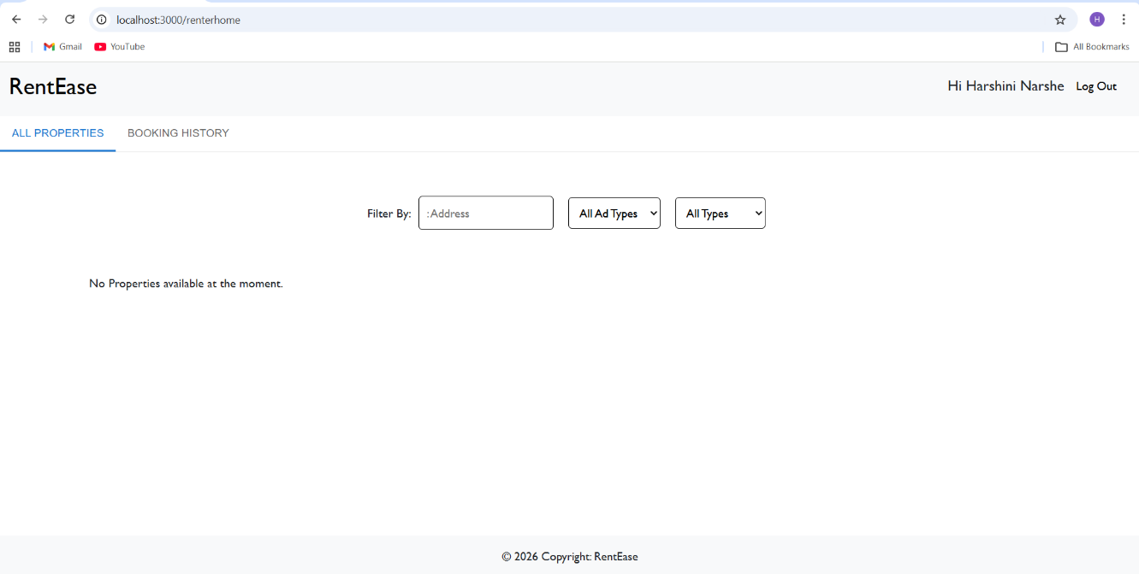
12. Known Issues
- Minor delay in booking status update (fixed in next patch)
- Image upload preview not instant in some browsers
- No payment integration yet

13. Future Enhancements
- Payment gateway integration for rental transactions
- Property recommendation using AI/ML
- Real-time chat between renter and owner
- Mobile app version
- Enhanced notifications and email reminders

